**Chapter 4 - Urinary System**

**All Lectures Uploaded on YouTube:**

[**https://tinyurl.com/fkm10-biology**](https://tinyurl.com/fkm10-biology)



### **4.1. Human Urinary System (Excretory System)**

* **Purpose**: Removes harmful metabolic waste products (like urea and uric acid), toxic substances (e.g. pesticides, drugs), excess salts and water.
* **Related Field**: Nephrology – study of kidney structure, function, and diseases.
* **Excretion**: Removal of metabolic waste from the body.

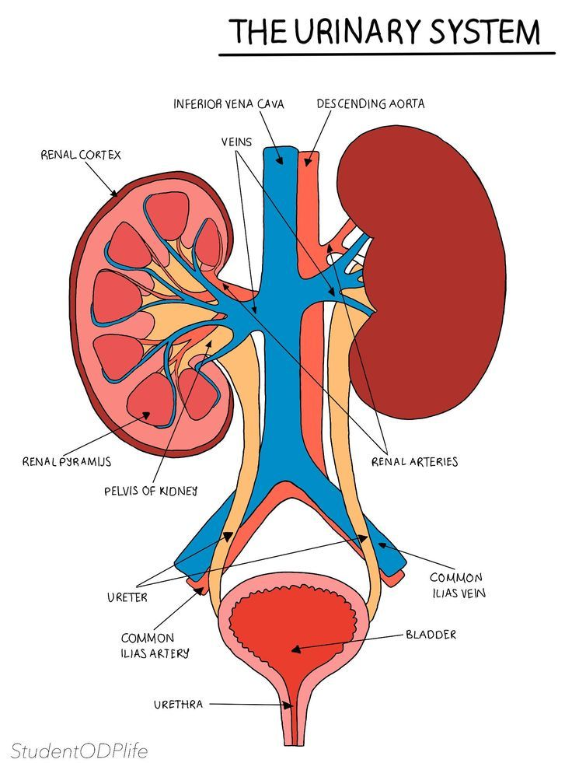

#### **Components of the Human Urinary System**

1. **Kidneys** (pair):
   * Reddish-brown, bean-shaped organs
   * Enclosed in a tough membrane called a **capsule**
   * The right kidney is slightly lower than the left.
2. **Ureters** (pair):
   * Muscular tubes that carry urine from the kidneys to the bladder.
3. **Urinary Bladder**:
   * Elastic muscular sac.
   * Stores urine.
4. **Urethra**:
   * The tube through which urine exits the body.

**4.2. Structure and Function of the Kidney**

* **Location**: At the back of the abdominal cavity, on either side of the vertebral column.
* **Structure**:
  + The **concave side** of the kidney faces the vertebral column.
  + Blood supply:
    - **The renal artery** brings blood from the dorsal aorta.
    - **The renal vein** carries blood to the inferior vena cava.
  + **Hilus**: Depression on the concave surface where the renal artery, vein, and nerves connect.

### **Structure of Kidney (Vertical Section)**

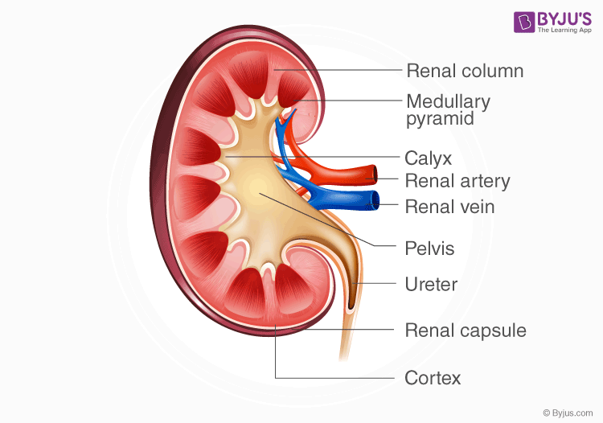

* **Renal Cortex**:
  + Outer dark region.
  + Contains many blood capillaries.
* **Renal Medulla**:  
  + Inner lighter region.
  + Contains cone-shaped **renal pyramids** and **renal columns**.
  + **Renal pelvis**: A funnel-shaped chamber collecting urine from the pyramids into the ureter.

**4.3. Nephron: Structural and Functional Unit of the Kidney**

* **Each kidney contains ~1 million nephrons**.
* **Parts**:
  + **Renal Corpuscle**:  
    1. **Bowman’s capsule**: Double-walled cup.
    2. **Glomerulus**: Tuft of capillaries inside Bowman’s capsule.
  + **Renal Tubule**:  
    1. **Proximal convoluted tubule**
    2. **Loop of Henle**
    3. **Distal convoluted tubule**
    4. **Collecting duct** → Leads into the renal pelvis

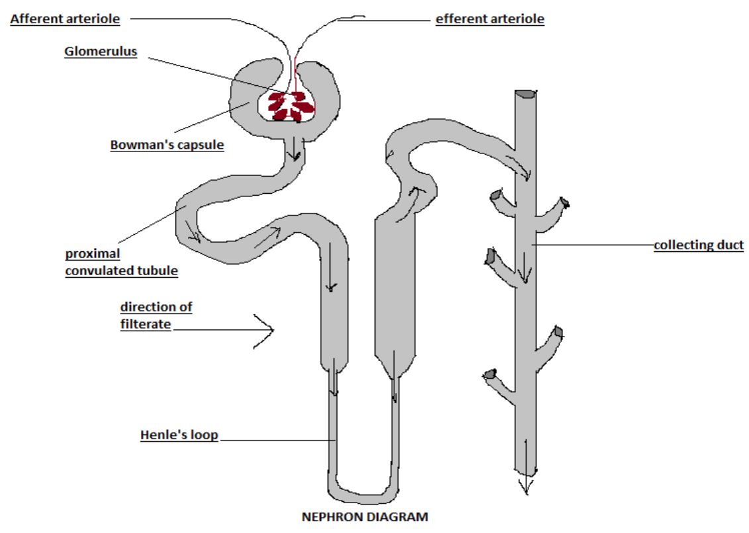

### **4.3.1. Functioning of the Nephron & Urine Formation**

#### **1. Glomerular Filtration:**

* Small molecules (water, salts, nutrients, waste) are filtered from the glomerulus into Bowman’s capsule by blood pressure.
* Proteins and blood cells remain in the blood.

#### **2. Selective Reabsorption:**

* 99% of water and useful substances (e.g. glucose, amino acids) are reabsorbed into the bloodstream.
* Occurs via osmosis, diffusion, and active transport.
* Mainly in the **proximal tubule**, the loop of Henle, and the **distal tubule**.

#### **3. Tubular Secretion:**

* Active removal of unwanted substances (e.g. H⁺, K⁺ ions, uric acid, drugs) from blood capillaries into the tubule.

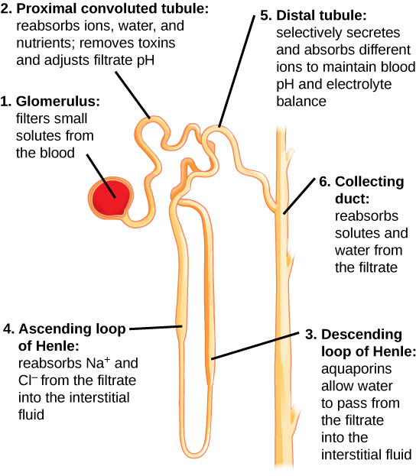

### **Urine Pathway (From Blood to Excretion):**

Liver → Urea → Blood → Kidney → Nephron → Glomerulus → Bowman’s capsule → Proximal tubule → Loop of Henle → Distal tubule → Collecting duct → Ureter → Bladder → Urethra → Urine leaves body

### **4.5. Osmoregulatory Function of the Kidney**

* **Regulates water and salt concentration** in blood.
* **Dilute blood** → Less water reabsorbed → More urine formed.
* **Concentrated blood** → More water reabsorbed → Less urine.
* The hypothalamus detects blood concentration, stimulates thirst, and releases the **antidiuretic hormone (ADH).**
* **ADH** increases water reabsorption in the kidneys.

### **4.6. Disorders of the Human Urinary System**

#### **Kidney Stones & Treatment**

* Formed by uric acid, calcium oxalate crystals.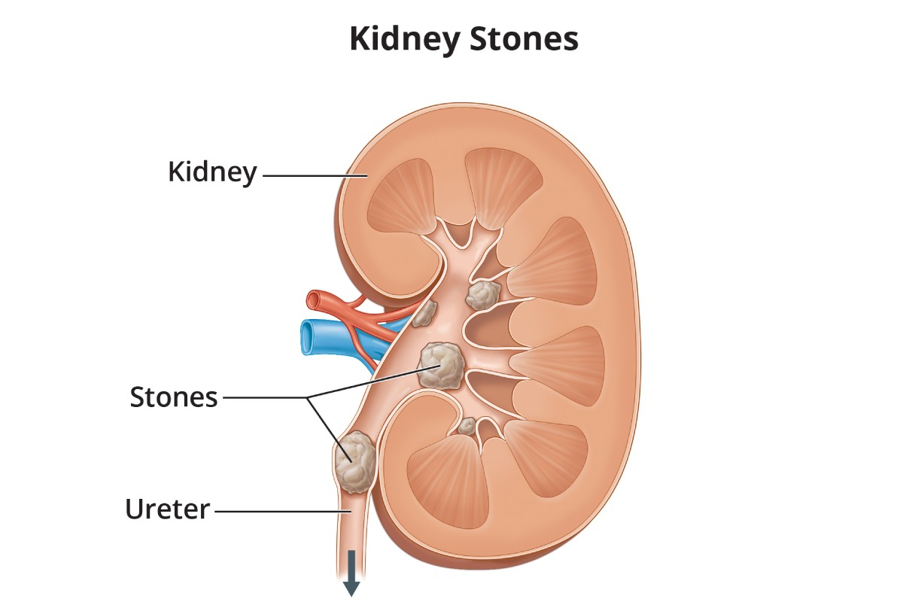
* Causes:
  + High calcium levels.
  + Low water intake.
  + Infections.
  + Genetics.
* **Treatment**:
  + **Lithotripsy**: Breaks stones using shock waves.
  + Surgery (if needed).

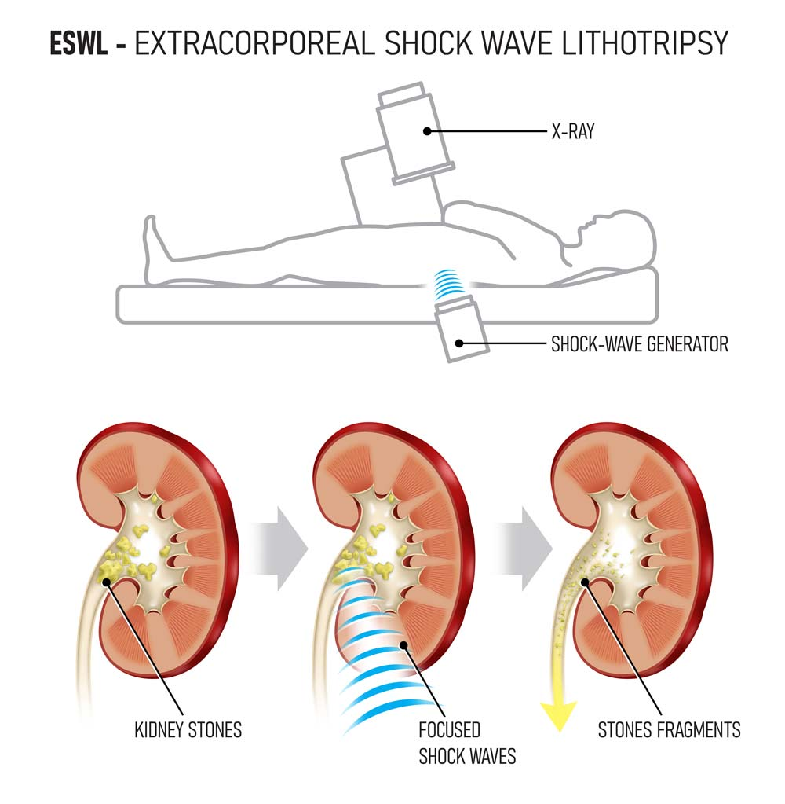

#### **Kidney Failure**

* If **one kidney fails**, a person can survive.
* **Both fail** → Fatal if untreated.
* **Acute failure**: Sudden, reversible.
* **Chronic failure**: Permanent loss of function.

#### **Causes of Kidney Failure**

1. **Diabetes** damages nephrons.
2. **High blood pressure** damages the kidney blood vessels.
3. **Autoimmune diseases** – e.g. lupus.
4. **Genetic diseases** – e.g. polycystic kidney disease.
5. **Urinary tract problems** – blockage.
6. **Medications** – e.g. lithium.
7. **Dehydration**
8. **Kidney trauma** – physical injury.
9. **Processed Foods** – can increase the risk of kidney damage

## **Dialysis**

* **Purpose**: Dialysis removes nitrogenous wastes and excess water from the blood when the kidneys fail.
* **Types of Dialysis**:
  1. **Haemodialysis**
  2. **Peritoneal Dialysis**

### **a. Haemodialysis**

* **Process**:
  + A **catheter** is inserted into a vein (usually in the arm).
  + Blood is passed through a machine called a **dialyser**.
  + Inside the dialyser, blood flows along a **semi-permeable membrane** (dialysis membrane).
  + The membrane allows **urea and other wastes** to diffuse out into the **dialysis fluid**.
  + Dialysis fluid already contains **sugars and salts**, so these do not diffuse from the blood.
  + **Clean blood** is returned to the body through another vein.
  + **Fresh dialysis fluid** enters from one end and **waste-filled fluid** leaves from the other.

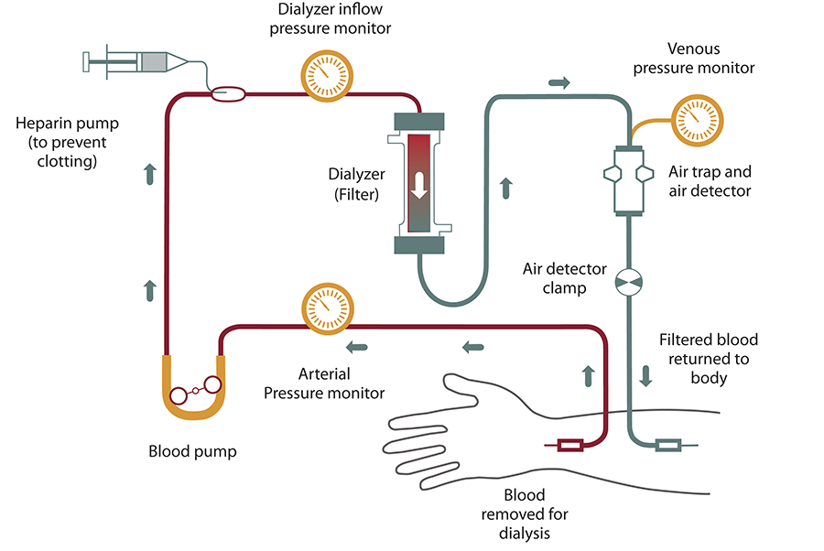

### **b. Peritoneal Dialysis**

* **Process**:
  + **Dialysis fluid** is pumped into the **peritoneal cavity** (space around the gut).
  + The **peritoneum** acts as the dialysis membrane.
  + Waste products from the blood diffuse across the peritoneal membrane into the dialysis fluid.
  + The fluid is left inside the abdomen for a few hours and then drained.
  + Can be done **at home**, but must be done **regularly (3–4 times a day)**.

## **Kidney Transplant**

* **Definition**: Transplanting a healthy kidney from a donor into a patient with kidney failure.
* **Source**: Kidney can be from a **living** or **deceased donor**.
* **Compatibility**:
  + The donor’s **tissue and blood chemistry** should match the recipient’s to reduce the risk of **tissue rejection**.
  + Immunosuppressive drugs are often needed to prevent rejection.
* **Benefit**: Offers a long-term solution compared to regular dialysis.

